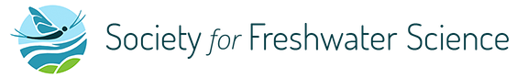
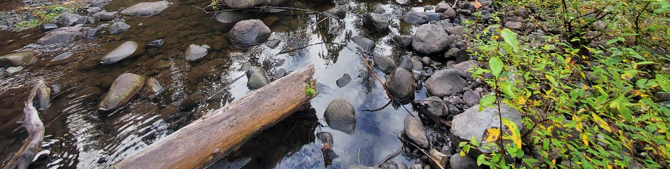
Pacific Northwest Chapter Annual Meeting 2024

When: Oct 23-24, 2024
Where: Olympia, Washington, at the Red Lion Governor Hotel
In-person & virtual

You are invited to attend our 2024 annual meeting. This meeting will be an in-person and hybrid format. If interested, you are also invited to submit an abstract for an individual presentation. Presentations should inform our understanding and management of freshwater aquatic ecosystems including rivers, streams, lakes, and wetlands in the Pacific Northwest. We are currently planning to facilitate sessions on macroinvertebrates, algae, mussels, restoration and monitoring, fish barrier (culvert) and dam removal. There will also be a workshop on Thursday afternoon - Drone acquisition 101: technology and capabilities of drones for freshwater science. Wednesday evening (5:30-8:30pm) will be the poster session and social (appetizers provided).

Conference registration is $50 and includes a complimentary swag item (for in-person attendees). Student registration is $25. Please register by October 9th. We encourage everyone to pay via card through Eventbrite, however, if you need to pay via check, please contact Oliver Miler (omiler@nwifc.org).
https://www.eventbrite.com/e/2024-sfs-pacific-northwest-chapter-annual-meeting-tickets-950333441907?aff=oddtdtcreator

Hotel rooms have been blocked out at the Red Lion Governor Hotel until October 9th under group code “PNW SFS”. Please call the hotel (360-352-7700) to reserve your room, or book here: Red Lion Inn & Suites Olympia, Governor Hotel - Reservations - Room Availability (synxis.com)

Oral presentations are limited to 15 minutes followed by 5 minutes for audience questions and next speaker transition. Please send abstracts to David Wooster (david.wooster@oregonstate.edu) no later than Monday September 30th, 2024. Abstracts should be <500 words and labeled as “[Last name]_[First 5 words of presentation title]”. Please include all authors and their affiliations, with the name of the presenting/corresponding author in bold type. Indicate if it will be an oral or poster presentation and if you plan to present in-person or virtually. Abstracts are to be submitted as an attachment in Word, not in the body of an e-mail. We hope to notify authors by October 4th.

We are pleased to offer two student awards to cover hotel lodging (2 nights) and registration. Scholarship forms are due to Shannon Claeson by September 30th (shannon.claeson@usda.gov). Attachment

Your silent auction donations, sponsors and registration fees make scholarships available. Please consider donating to this year's silent auction. For donations, advertising or sponsorship opportunities at this year's conference please contact Oliver Miler (Treasurer; omiler@nwifc.org) for more information.

Please contact Shannon Claeson (shannon.claeson@usda.gov) or David Wooster (david.wooster@oregonstate.edu) with any concerns or questions.

