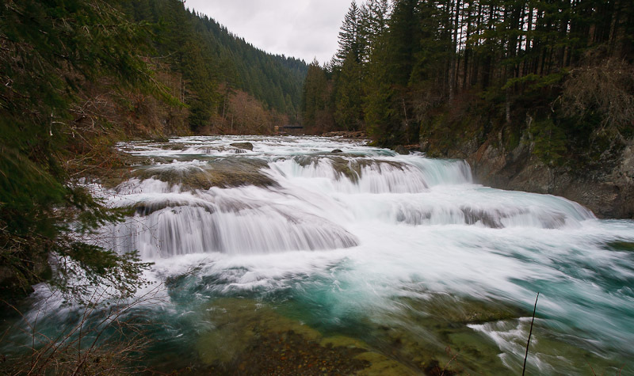
Pacific Northwest Chapter | Society for Freshwater Science 2019 Annual Meeting

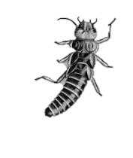
Where and When?
Newport, Oregon Agate Beach Inn
Nov. 6 – 8, 2019
Call for Presentations
- Translational Ecology
- Taxonomic Advancements
- Watershed Ecohydrology
- Bioassessment Landscape Applications
- Oregon Coast Natural History
- Estuaries and Wetlands

Mark your calendars! Our 2019 Annual Chapter Meeting will be held November 6-8, 2019 in beautiful Newport, Oregon. A block of rooms has been reserved at the Agate Beach Inn overlooking the ocean. Interested parties may book rooms online (Group Z34ZL9C9) or contact front desk agents at (541) 265-9411 and reference the SFS-Society of Freshwater Science to receive the group rate. Rooms are available on a first come, first serve basis for the group rate through the weekend (11/5 - 11/10). For more information about the beauty and recreation opportunities in Newport area, check out: (www.discovernewport.com), (www.newportchamber.org/visitors), or (www.aquarium.org/).
You are invited to submit a proposal for an individual presentation, multiple author session, or roundtable discussion during our 2019 meeting. Group collaboration is encouraged to provide themed sessions. Presentations should inform our understanding and management of aquatic ecosystems in the Pacific Northwest. Presentation proposals will be accepted until October 4, 2019. Presentations will be selected no later than October 11, 2019. If you have a presentation idea, we want to hear from you!
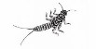
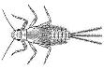
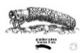
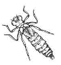
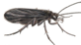
To support student participation, address growing venue costs, and advance member development the steering committee is proposing a registration fee this year. Watch your inbox for workshop announcements!
Registration PNW SFS Member: $25 Non-Member: $50
Please register online at
2019 PNW SFS Meeting
Please contact Bob Danehy (robertjdanehy@gmail.com, 541-731-2041) or Chris Zell (zell.christopher@epa.gov, 206-553-1353) if you have any questions or need additional information. Thank you to our conference steering committee: Bob Danehy, Chris Zell, Dorene MacCoy, Francine Mejia, Robert Plotnikoff, and Hannah Harris.

